2024-25 GRCC Men’s Basketball Roster

NO | NAME | POS | HT | WT | YR | HOMETOWN/HIGH SCHOOL
0 | Mason Wilcox | G | 6’1 | 175 | SO | Boyne City, MI / Boyne City (’23)
1 | Bashir Neely | G | 6’3 | 170 | SO | Benton Harbor, MI / Grand Haven (’22)
2 | Jaden Montague | G | 6’3 | 170 | FR | Cadillac, MI / Cadillac (’23)
3 | Jacob DeGroot | G | 6’3 | 185 | SO | Grand Rapids, MI / Hamilton (’23)
4 | Maurice Bowman | F | 6’5 | 230 | FR | Kentwood, MI / East Kentwood (’23)
5 | Marshaun Flakes | G | 6’2 | 170 | FR | Kentwood, MI / East Kentwood (’23)
10 | Gaden Muxlow | W | 6’4 | 200 | FR | Brown City, MI / Brown City (’23)
11 | Jack Agema | G | 5’10 | 150 | SO | Grand Rapids, MI / Calvin Christian (’23)
12 | Nicolas Knuutila | W | 6’5 | 175 | FR | Tanpere, Finland / Palkane (’23)
13 | Tyran Thomas | G | 6’3 | 165 | FR | Grand Rapids, MI / Northview (’23)
14 | Darius Baker | W | 6’4 | 175 | FR | Kalamazoo, MI / Parchment (’24)
20 | Zachary Carlson | G | 6’0 | 165 | FR | Ishpeming, MI / Westwood (’22)
23 | Javon Golson | W | 6’4 | 175 | SO | Detroit, MI / Denby (’17)
24 | Benjamin Koubek | W | 6’3 | 195 | FR | Ocala, FL / The Villages (’24)
25 | Micah Estelle | F | 6’4 | 220 | FR | Hopkins, MI / Hopkins (’24)
32 | Adam Hardy | W | 6’7 | 190 | FR | Ada, MI / Forest Hills Eastern (’24)
44 | Ethan Bennett | F | 6’7 | 185 | FR | McBain, MI / Northern Michigan Christian (’24)
55 | Zeekeal Jackson | G | 6’2 | 180 | FR | Grand Rapids, MI / Wellspring Prep (’23)

Head Coach: Joe Fox (4th year)
Assistant Coaches: DeQuaveon Stuckey, Daryl Kirkland, Alex Ehnis
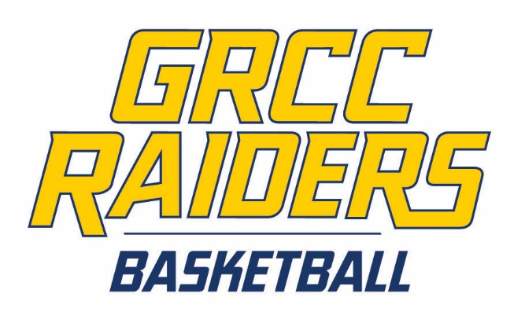
Manager: Matthew Quillan
Statistician: Justin Studnicky
Sports Information Director: Ben Brown
Athletic Trainer: Mackenzie Ondersma

